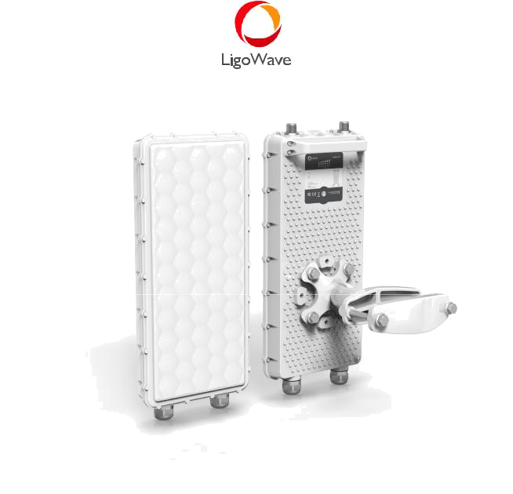

LigoBASE 5-N/ 5-90

High-performance 5 GHz base-station


COPYRIGHT ©2017 LIGOWAVE
COPYRIGHT ©2017 LIGOWAVE
Available models

LigoBASE 5-N LigoBASE 5-90
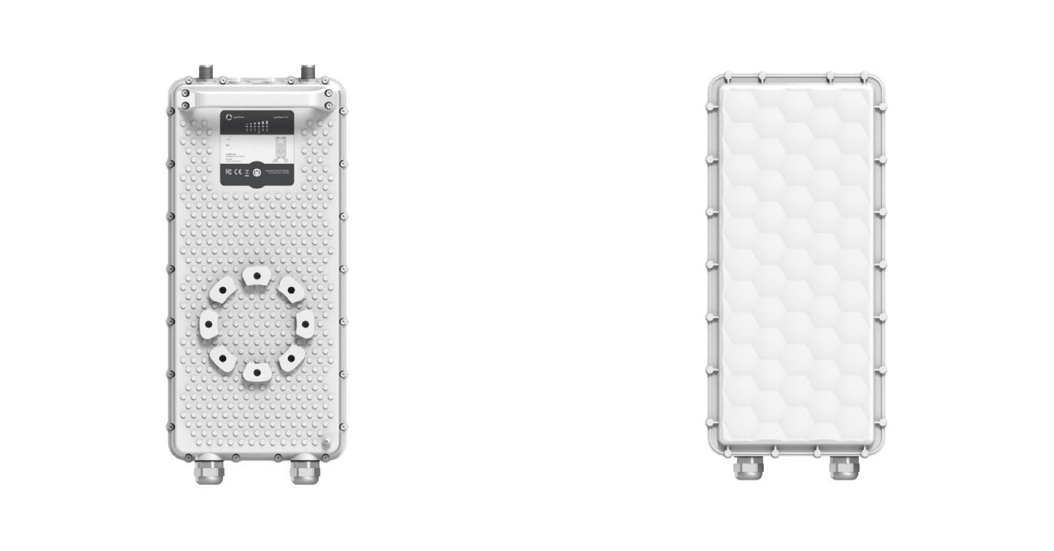

Base-station with N-type | Base-station with and
connectors for the external | integrated 17 dBi 90 degree
antenna | sector antenna.
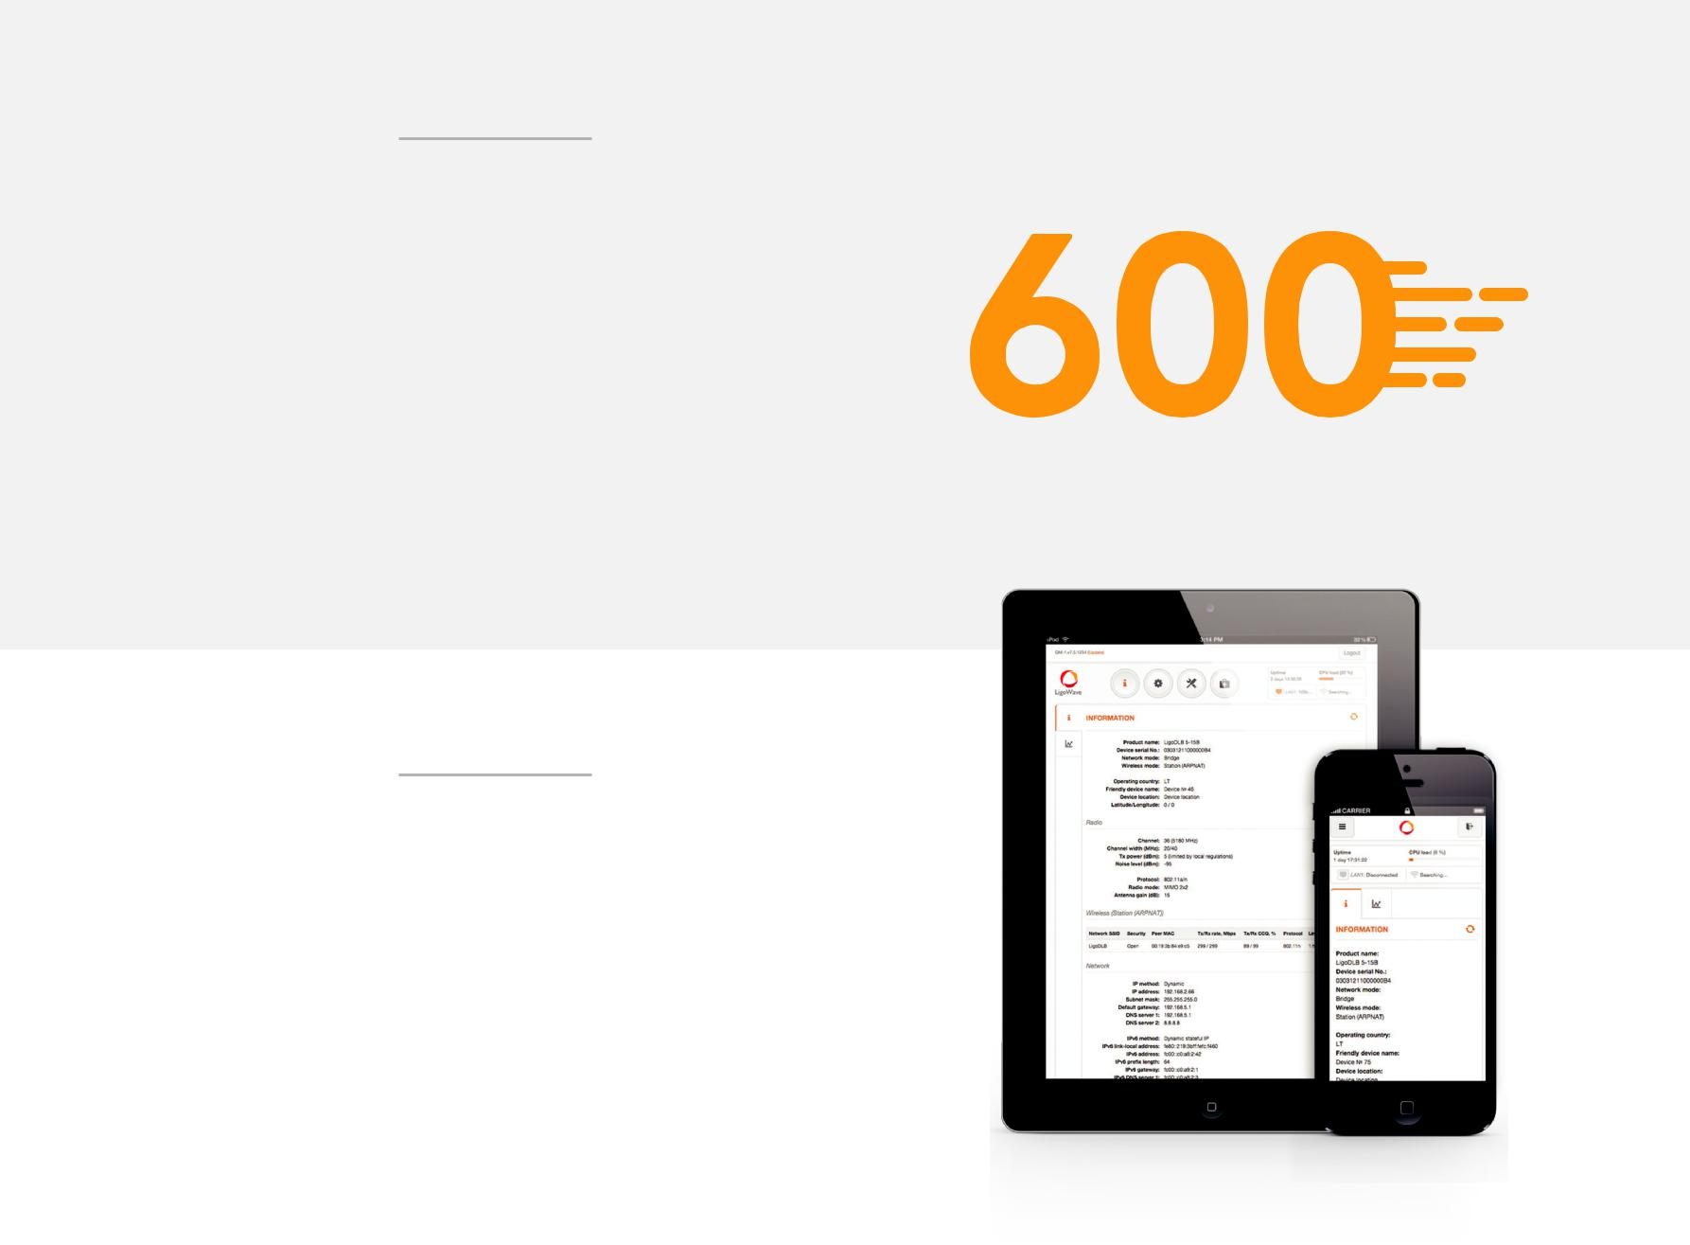

Incredible performance

LigoPTMP series point to multipoint system delivers

600+ Mbps throughput via its unique and powerful RF

design that supports up to 256QAM modulation and

31 dBm output power. 1.2 GHz dedicated CPU ensures

swift data processing and high packet per second rate

(PPS) which is important for real time data transmission

applications. Equipped with two Gigabit Ethernet ports,

one with PoE passthrough, the unit allows powering and

connecting two devices on the tower (another LigoBASE

or IP camera). LigoBASE incorporates integrated surge and ESD protection according to IEC standards passing Class 4 requirements. Additionally, weatherproof IP-67 standard rated enclosure design allows using the equipment in any climate conditions.

LigoWave OS

The full featured operating system makes LigoPTMP

devices ideal not only for WISPs and operators, but also for security, enterprise or industrial applications. Proprietary data transmission protocol (W-Jet V) ensures smooth performance even in noisy areas at the same time delivering high capacity, low latency and high packet per second rate. QoS (quality of service) mechanism allows prioritizing mission critical data and efficiently transmitting voice, video or other real time data over the wireless network. Essential tools like spectrum analyzer, site survey, antenna alignment and others are included.

COPYRIGHT ©2017 LIGOWAVE
Easy pre-configuration and maintenance

A new approach to setting up and maintaining your network
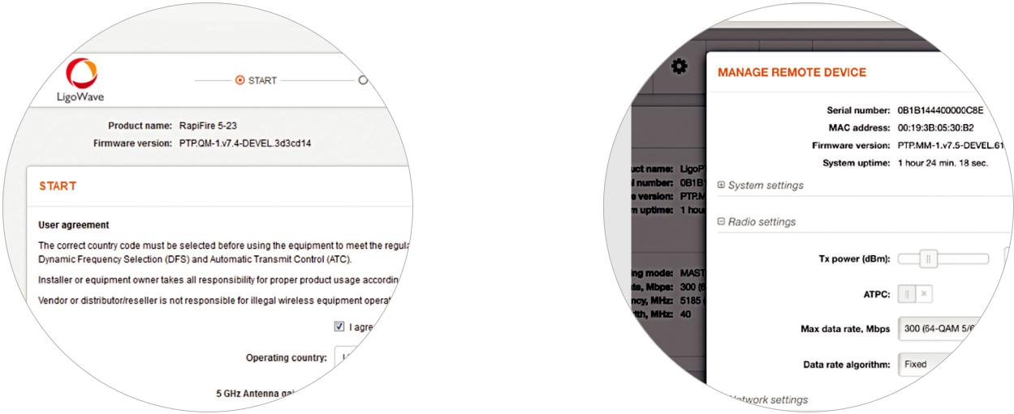

Setup Wizard | Single side configuration
Guides the installer through the important | Link parameters are automatically applied to
steps of the set-up process. | subscriber units once set on the base-station
 | side.
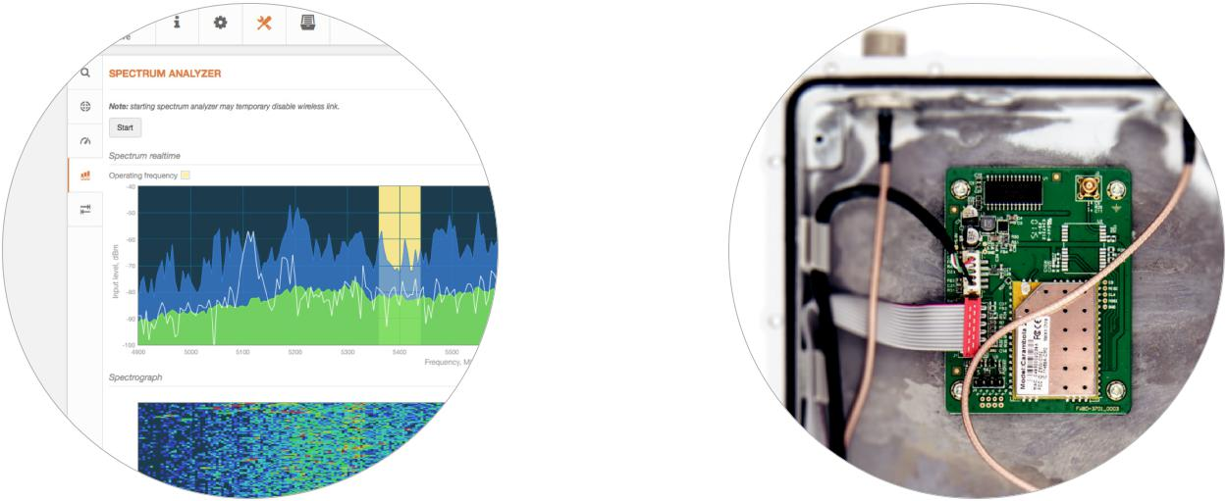

Spectrum analyzer | 2.4 GHz access radio
Demonstrates the current noise floor in a | An internal 2.4 GHz radio allows access into
waveform and waterfall graphs. | the LigoBASE GUI by wireless connection with
 | any WIFI equipped device.

COPYRIGHT ©2017 LIGOWAVE
Pre-configuration

Multiple options to pre-configure LigoPTMP devices are displayed in a scheme below. Devices can be connected with each other using wired or wireless connectivity. End-user device can also connect to the LigoBASE device using 2.4 GHz access radio or using wire to the Ethernet port of the LigoBASE device. LigoPTMP devices can be discovered using Bonjour, CDP and SSDP protocols as well.

Wireless
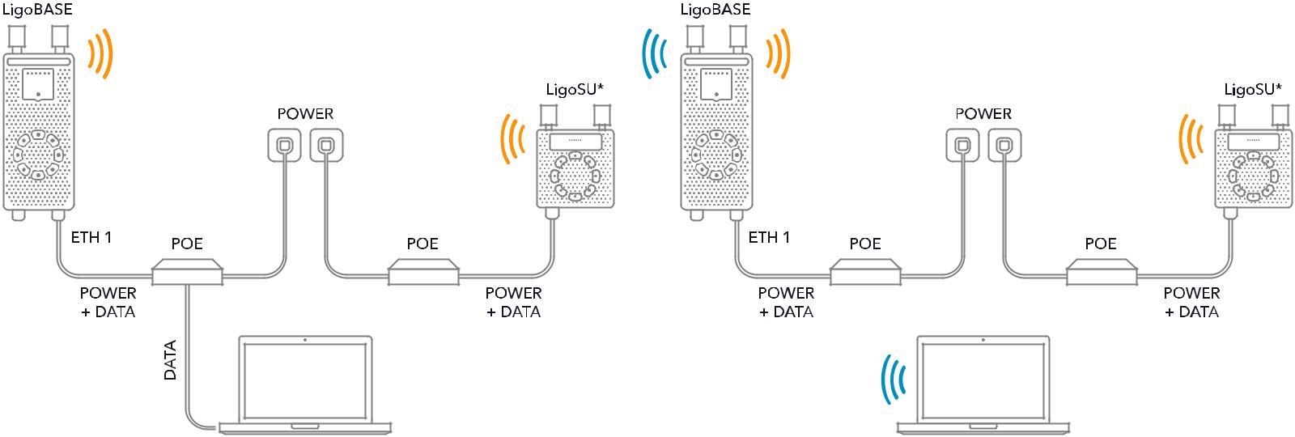

*Multiple LigoSU units can be connected to the LigoBASE

Wired
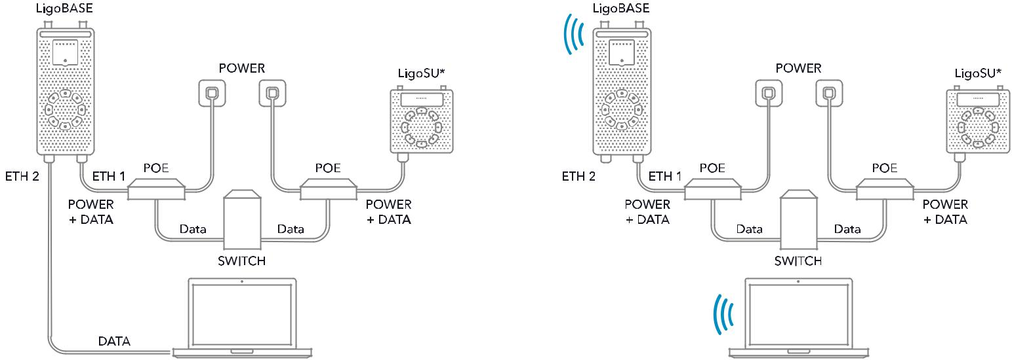

*Multiple LigoSU units can be connected to the LigoBASE

COPYRIGHT ©2017 LIGOWAVE
802.3af/at inserter
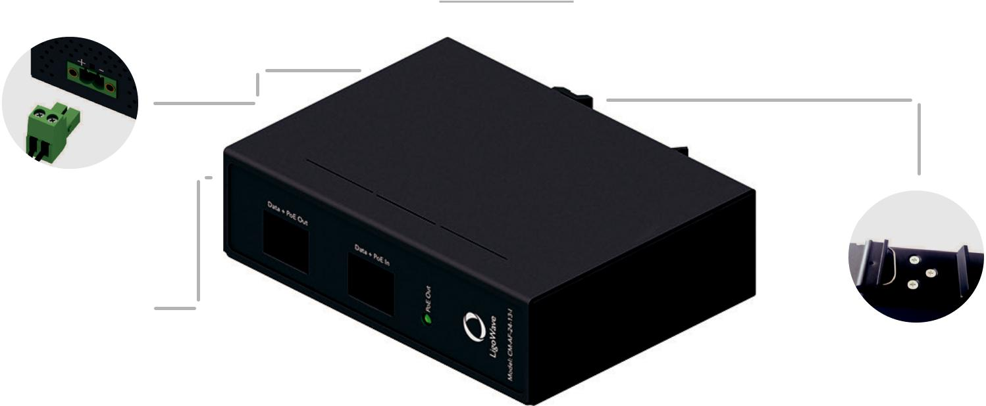

DC input connector

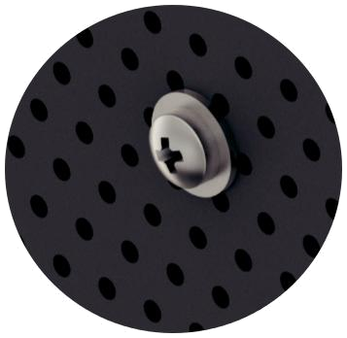

DIN rail mounting

Grounding pin
Electrical specifications |  | Physical specifications
DC input voltage range | 44.0–57.0V | Data input jack | RJ45
PoE output | IEEE 802.3af/at compliant | Data + Power output jack | RJ45
Output power | up to 28W | Dimensions | 117x87x34mm
Power out pins | RJ45 1,2,4,5 (+) and 3,6,7,8 (-) | Weight | 270g
Data rate | 10/100/1000Mbps | Operating temperature | -40 to +65C
Surge protection | 2kV line to line, | UTP/FTP cable length | 100m total
 | 6kV line to ground (output port) |  | (from switch to the device)

COPYRIGHT ©2017 LIGOWAVE
Radio

Wireless protocol |  | W-Jet V
Radio mode |  | MIMO 2x2
Frequency range |  | 4.900 - 6.100 GHz (FCC: 4.940 - 4.990 GHz, 5.150-5.250 GHz, 5.725-5.850 GHz)
Channel size |  | 5, 10, 20, 40, 80 MHz
Modulation schemes |  | OFDM (256-QAM, 64-QAM, 16-QAM, QPSK, BPSK)
Data rates @ 80 MHz |  | 866, 780, 650, 585, 520, 390, 260, 195, 130, 65 Mbps
Duplexing scheme |  | TDD
Error correction |  | BCC, LDPC
Modulation, Mbps | 866 | 780 | 650 | 585 | 520 | 390 | 260 | 195 | 130 | 65
TX Power, dBm | 25 | 26 | 26 | 27 | 27 | 28 | 29 | 30 | 30 | 31
Receive sensitivity, dBm | -71 | -73 | -77 | -79 | -80 | -84 | -87 | -92 | -94 | -97
Antenna
LigoBASE 5-90 |  | Integrated 17 dBi dual-pol 90 degree sector antenna
LigoBASE 5-N |  | 2 N-type connectors
Wired
First Interface |  | 10/100/1000 Base-T with PoE IN (RJ-45)
Second Interface |  | 10/100/1000 Base-T with PoE OUT (RJ-45)
Physical
Dimensions without mount:
LigoBASE 5-90 |  | Length 389 mm (15.3‘’), width 174 mm (6.8‘’), height 51 mm (2‘’)
LigoBASE 5-N |  | Length 399 mm (15.7‘’), width 174 mm (6.8‘’), height 47 mm (1.8‘’)
Mount length till pole |  | 124 mm (4.8‘’)
Weight including mount:
LigoBASE 5-90 |  | 2.77 kg (6.1 lb)
LigoBASE 5-N |  | 3 kg (6.6 lb)
Power
Power input method, voltage |  | PoE 802.3af, isolated 42 - 57 VDC
Power consumption (max) |  | 8.6 W
Power output method, voltage |  | PoE 802.3af, 48 VDC, 12.95W maximum
PoE inserter and AC/DC adapter are included
Environmental
Operating temperature |  | -40°C (-40 F) ~ +65°C (+149 F)
Humidity |  | 0 ~ 90 % (non-condensing)


COPYRIGHT ©2017 LIGOWAVE
Software features

- Wizard for fast link setup

• Centralized control from LigoBASE: A) Common wireless link parameters; B) Individual LigoSU parameters

- Smart Auto-channel

- Robust data security

- QoS with hardware acceleration

- Spectrum analyzer

- Wireless signal and device state indication on RGB LEDs

- Dual firmware image

Management

Dedicated 2.4 GHz radio for management

System monitoring

System configuration

SNMP, GUI/HTTP(S), Shell/SSH and WNMS GUI/HTTP(S) and WNMS

Regulatory

Certification FCC/IC/CE

Antenna specifications

 | V Pol |  |  |  |  |  | H Pol
0 |  |  | 0 |  |  | 0 |  | 0
30 | 330 | 30 | 330 |  | 30 | 330 | 30 | 330
60 | 300 | 60 |  | 300 | 60 | 300 | 60 | 300
90 | 270 | 90 |  | 270 | 90 | 270 | 90 | 270
120 | 240 | 120 |  | 240 | 120 | 240 | 120 | 240
150 | 210 | 150 | 210 |  | 150 | 210 | 150 | 210
180 |  |  | 180 |  |  | 180 |  | 180
Azimuth |  |  | Elevation |  |  | Azimuth |  | Elevation
Frequency range |  |  |  |  |  |  |  | 4.9 - 5.9 GHz
Gain |  |  |  |  |  |  |  | 17 dBi
Polarization |  |  |  |  |  |  |  | Dual linear
Cross-pol Isolation |  |  |  |  |  |  |  | 24 dBi
VSWR |  |  |  |  |  |  |  | <1.7
Azimuth beamwidth (H pol) |  |  |  |  |  |  |  | 90 deg
Azimuth beamwidth (V pol) |  |  |  |  |  |  |  | 90 deg
Elevation beamwidth |  |  |  |  |  |  |  | 20 deg



LigoBASE 5-N/ 5-90

Copyright © 2017 LigoWave. All rights reserved. LigoWave, the LigoWave logo, are trademarks of LigoWave. All other company and product names may be trademarks of their respective companies. While every effort is made to ensure the information given is accurate, LigoWave does not accept liability for any errors or mistakes which may
arise. Specifications and other information in this document may be subject to change without notice. To learn more about LigoWave products, visit www.ligowave.com.
COPYRIGHT ©2017 LIGOWAVE

