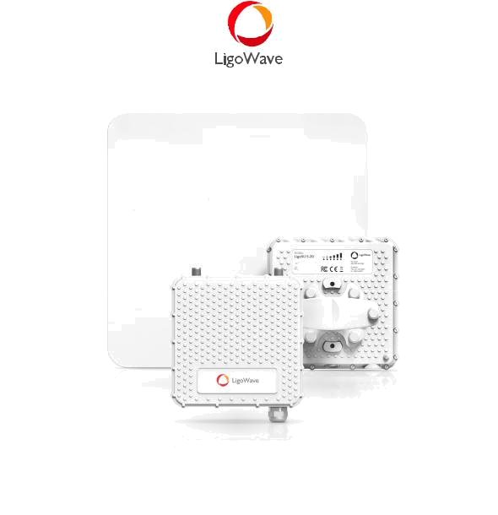

LigoSU 5-N/ 5-20/ 5-23

High-performance 5 GHz subscriber unit


COPYRIGHT ©2017 LIGOWAVE
COPYRIGHT ©2017 LIGOWAVE
Available models

LigoSU 5-N LigoSU 5-20 LigoSU 5-23
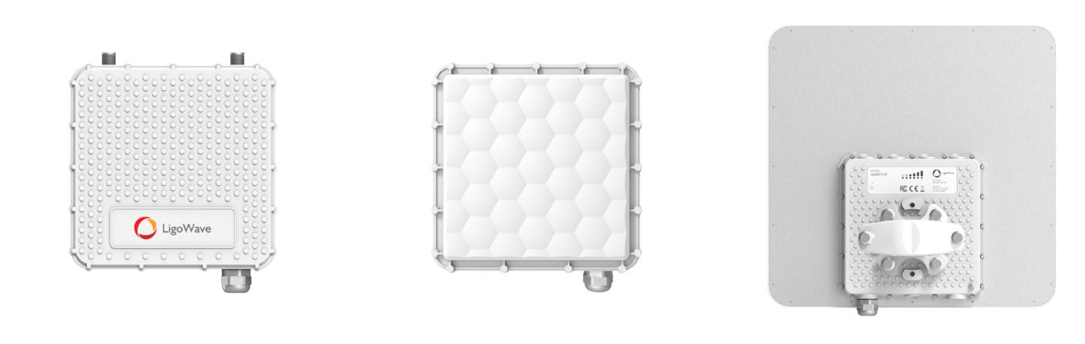

Subscriber unit with N-type | Subscriber unit with an integrated | Subscriber unit with an integrated
connectors for the external antenna. | directional 20 dBi antenna. | directional 23 dBi antenna.
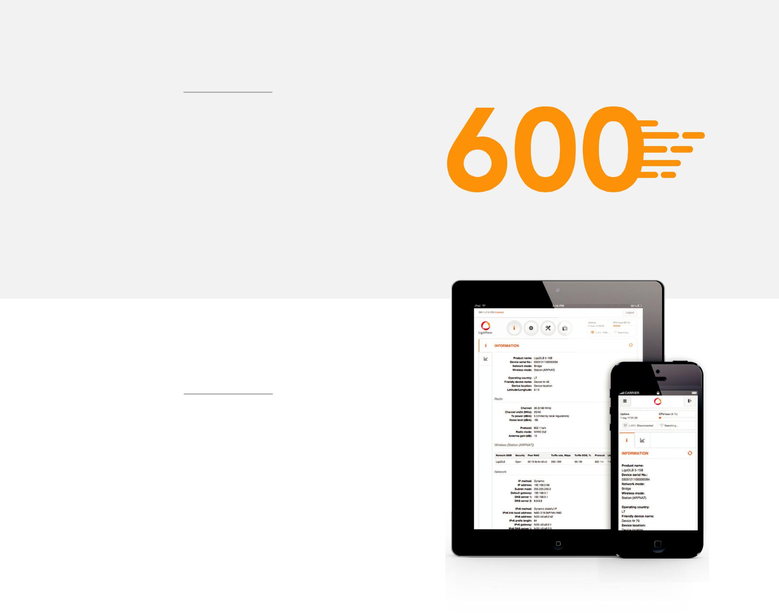

Incredible performance

LigoPTMP series point to multipoint system delivers 600+

Mbps throughput via its unique and powerful RF design

that supports up to 256QAM modulation and 30 dBm

output power. 720 MHz dedicated CPU ensures swift data

processing and high packet per second rate (PPS) which

is important for real time data transmission applications.

Gigabit Ethernet port supporting 802.3af/at standard allows

powering the devices with PoE switches. Weatherproof

IP-67 standard rated enclosure design allows using the

equipment in any climate conditions.

LigoWave OS

The full featured operating system makes LigoPTMP

devices ideal not only for WISPs and operators, but also for security, enterprise or industrial applications. Proprietary data transmission protocol (W-Jet V) ensures smooth performance even in noisy areas at the same time delivering high capacity, low latency and high packet per second rate. QoS (quality of service) mechanism allows prioritizing mission critical data and efficiently transmitting voice, video or other real time data over the wireless network. Essential tools like spectrum analyzer, site survey, antenna alignment and others are included.

COPYRIGHT ©2017 LIGOWAVE
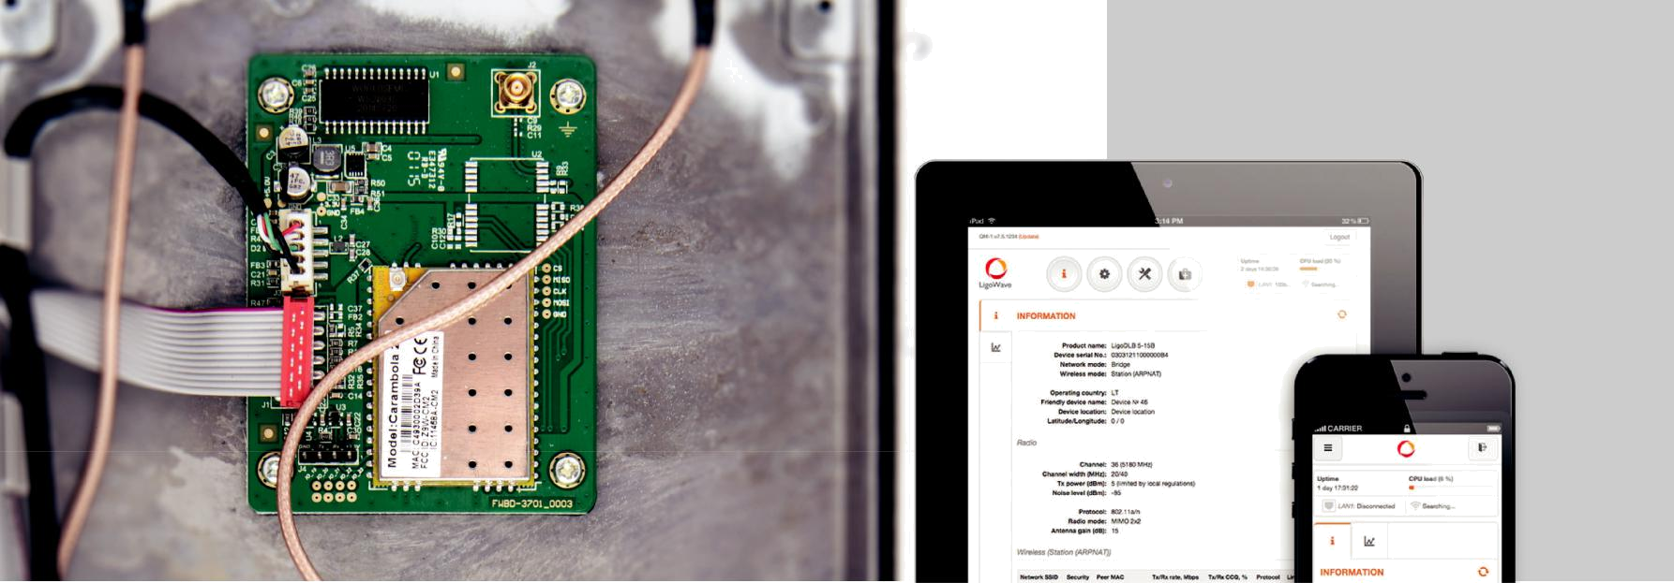

Easy pre-configuration and maintenance

A new approach to setting up and maintaining your network
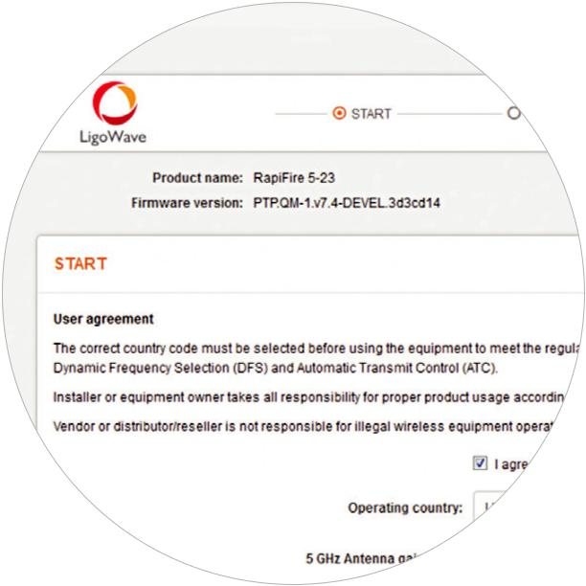

Setup Wizard

Guides the installer through the important steps of the set-up process.
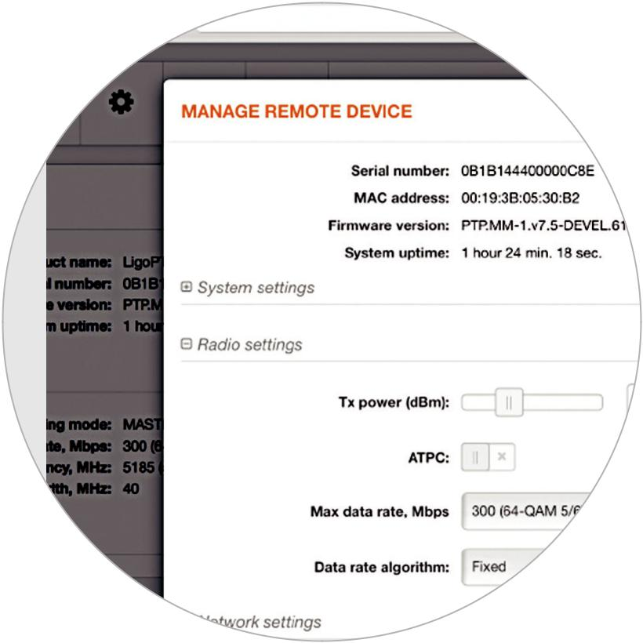

Single side configuration

Link parameters are automatically applied to subscriber units once set on the base-station side.
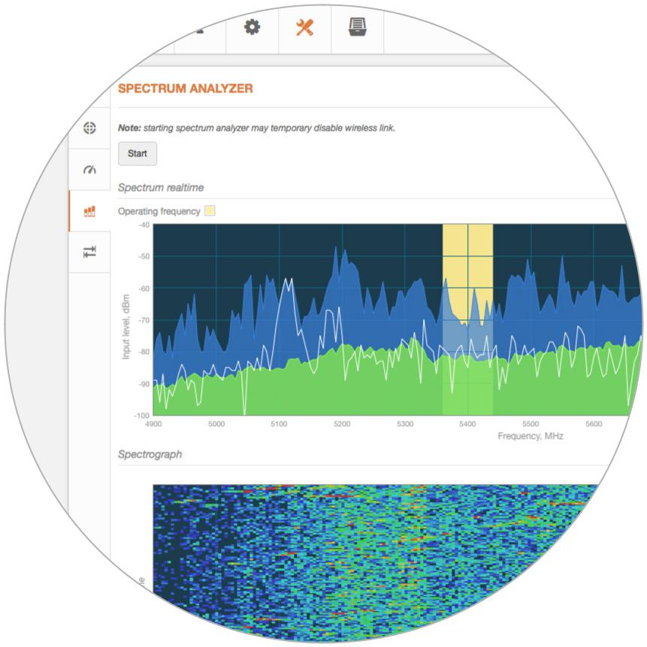

Spectrum analyzer

Demonstrates the current noise floor in a waveform and waterfall graphs.

COPYRIGHT ©2017 LIGOWAVE
Pre-configuration

Multiple options to pre-configure LigoPTMP devices are displayed in the scheme below. Devices can be connected with each other using wired or wireless connectivity. End-user device can also connect to the LigoBASE device using 2.4 GHz access radio or using wire to the Ethernet port of the LigoBASE device. LigoPTMP devices can be discovered using Bonjour, CDP and SSDP protocols as well.

Wireless
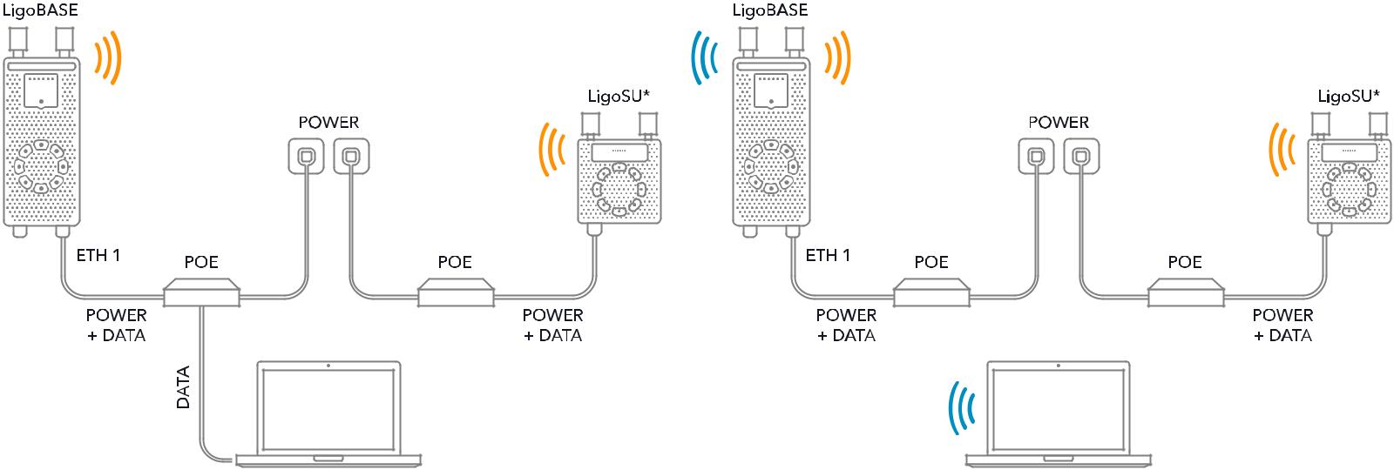

*Multiple LigoSU units can be connected to the LigoBASE

Wired
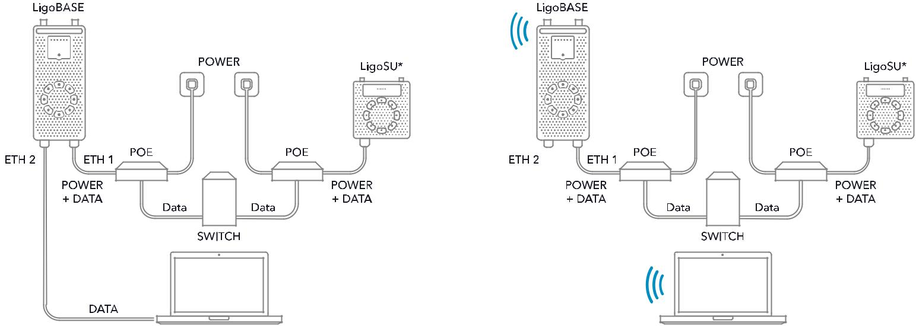

*Multiple LigoSU units can be connected to the LigoBASE

COPYRIGHT ©2017 LIGOWAVE
Radio

Wireless protocol |  | W-Jet V
Radio mode |  | MIMO 2x2
Frequency range |  | 4.900 - 6.100 GHz (FCC: 4.940 - 4.990 GHz, 5.150-5.250 GHz, 5.725-5.850 GHz)
Channel size |  | 5, 10, 20, 40, 80 MHz
Modulation schemes |  | OFDM (256-QAM, 64-QAM, 16-QAM, QPSK, BPSK)
Data rates @ 80 MHz |  | 866, 780, 650, 585, 520, 390, 260, 195, 130, 65 Mbps
Duplexing scheme |  | TDD
Error correction |  | BCC, LDPC
Modulation, Mbps | 866 | 780 | 650 | 585 | 520 | 390 | 260 | 195 | 130 | 65
TX Power, dBm | 24 | 25 | 25 | 26 | 27 | 28 | 28 | 29 | 29 | 30
Receive sensitivity, dBm | -64 | -66 | -70 | -72 | -74 | -78 | -81 | -85 | -88 | -90
Antenna
LigoSU 5-N |  | 2 N-type connectors
LigoSU 5-20 |  | Integrated directional dual-pol 20 dBi antenna
LigoSU 5-23 |  | Integrated directional dual-pol 23 dBi panel
Wired
Interface |  | 10/100/1000 Base-T with PoE IN (RJ45)
Physical
Dimensions without mount:
LigoSU 5-N |  | Length 198 mm (7.7‘’), width 198 mm (7.7‘’), height 46 mm (1.8‘’)
LigoSU 5-20 |  | Length 198 mm (7.7‘’), width 198 mm (7.7‘’), height 50.5 mm (1.9‘’)
LigoSU 5-23 |  | Length 387 mm (15.2‘’), width 379 mm (15.2‘’), height 50 mm (15.2‘’)
Mount length till pole |  | 130 mm (5.1‘’)
Weight including mount:
LigoSU 5-N |  | 2.05 kg (4.5 lb)
LigoSU 5-20 |  | 2.00 kg (4.4 lb)
LigoSU 5-23 |  | 3.24 kg (7.1 lb)


Power

Power input method, voltage

Power consumption (max)

PoE included

PoE 802.3af, isolated 42 - 57 VDC

10 W

Environmental

Operating temperature -40°C (-40 F) ~ +65°C (+149 F)

Humidity 0 ~ 90 % (non-condensing)

Software features

- Smart Auto-channel

- Robust data security

- QoS with hardware acceleration

- Spectrum analyzer

- Dual firmware image

- Client device is controlled via Base Station

Regulatory

Certification FCC/IC/CE

COPYRIGHT ©2017 LIGOWAVE
Antenna specifications

LigoSU 5-20
 |  | V Pol |  |  |  |  |  | H Pol
0 |  |  |  | 0 |  |  | 0 |  |  | 0
30 | 330 |  | 30 | 330 |  | 30 | 330 |  | 30 | 330
60 | 300 | 60 |  | 300 | 60 |  | 300 | 60 |  | 300
90 | 270 | 90 |  | 270 | 90 |  | 270 | 90 |  | 270
120 | 240 | 120 |  | 240 | 120 |  | 240 | 120 |  | 240
150 | 210 |  | 150 | 210 |  | 150 | 210 |  | 150 | 210
180 |  |  |  | 180 |  |  | 180 |  |  | 180
Azimuth |  |  |  | Elevation |  |  | Azimuth |  |  | Elevation
LigoSU 5-23
 |  | V Pol |  |  |  |  |  | H Pol
0 |  |  |  | 0 |  |  | 0 |  |  | 0
30 | 330 |  | 30 | 330 |  | 30 | 330 |  | 30 | 330
60 | 300 | 60 |  | 300 | 60 |  | 300 | 60 |  | 300
90 | 270 | 90 |  | 270 | 90 |  | 270 | 90 |  | 270
120 | 240 | 120 |  | 240 | 120 |  | 240 | 120 |  | 240
150 | 210 |  | 150 | 210 |  | 150 | 210 |  | 150 | 210
180 |  |  |  | 180 |  |  | 180 |  |  | 180
Azimuth |  |  |  | Elevation |  |  | Azimuth |  |  | Elevation

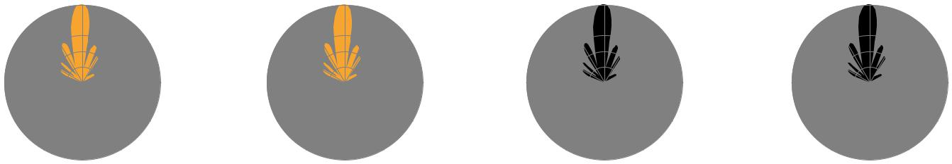

Internal antenna

Model name | LigoSU 5-20 | LigoSU 5-23
Frequency range | 5.1 - 5.9 GHz | 4.9 - 5.9 GHz
Gain | 20 dBi | 23 dBi
Polarization | Dual linear | Dual linear
Cross-pol Isolation | 27 dBi | 27 dBi
VSWR | <1.8 | 1.5:1
Azimuth beamwidth (H pol) | 16 deg | 6 deg
Azimuth beamwidth (V pol) | 16 deg | 7 deg
Elevation beamwidth | 16 deg | 9 deg


LigoSU 5-N/ 5-20/ 5-23

Copyright © 2017 LigoWave. All rights reserved. LigoWave, the LigoWave logo, are trademarks of LigoWave. All other company and product names may be trademarks of their respective companies. While every effort is made to ensure the information given is accurate, LigoWave does not accept liability for any errors or mistakes which may
arise. Specifications and other information in this document may be subject to change without notice. To learn more about LigoWave products, visit www.ligowave.com.
COPYRIGHT ©2017 LIGOWAVE

