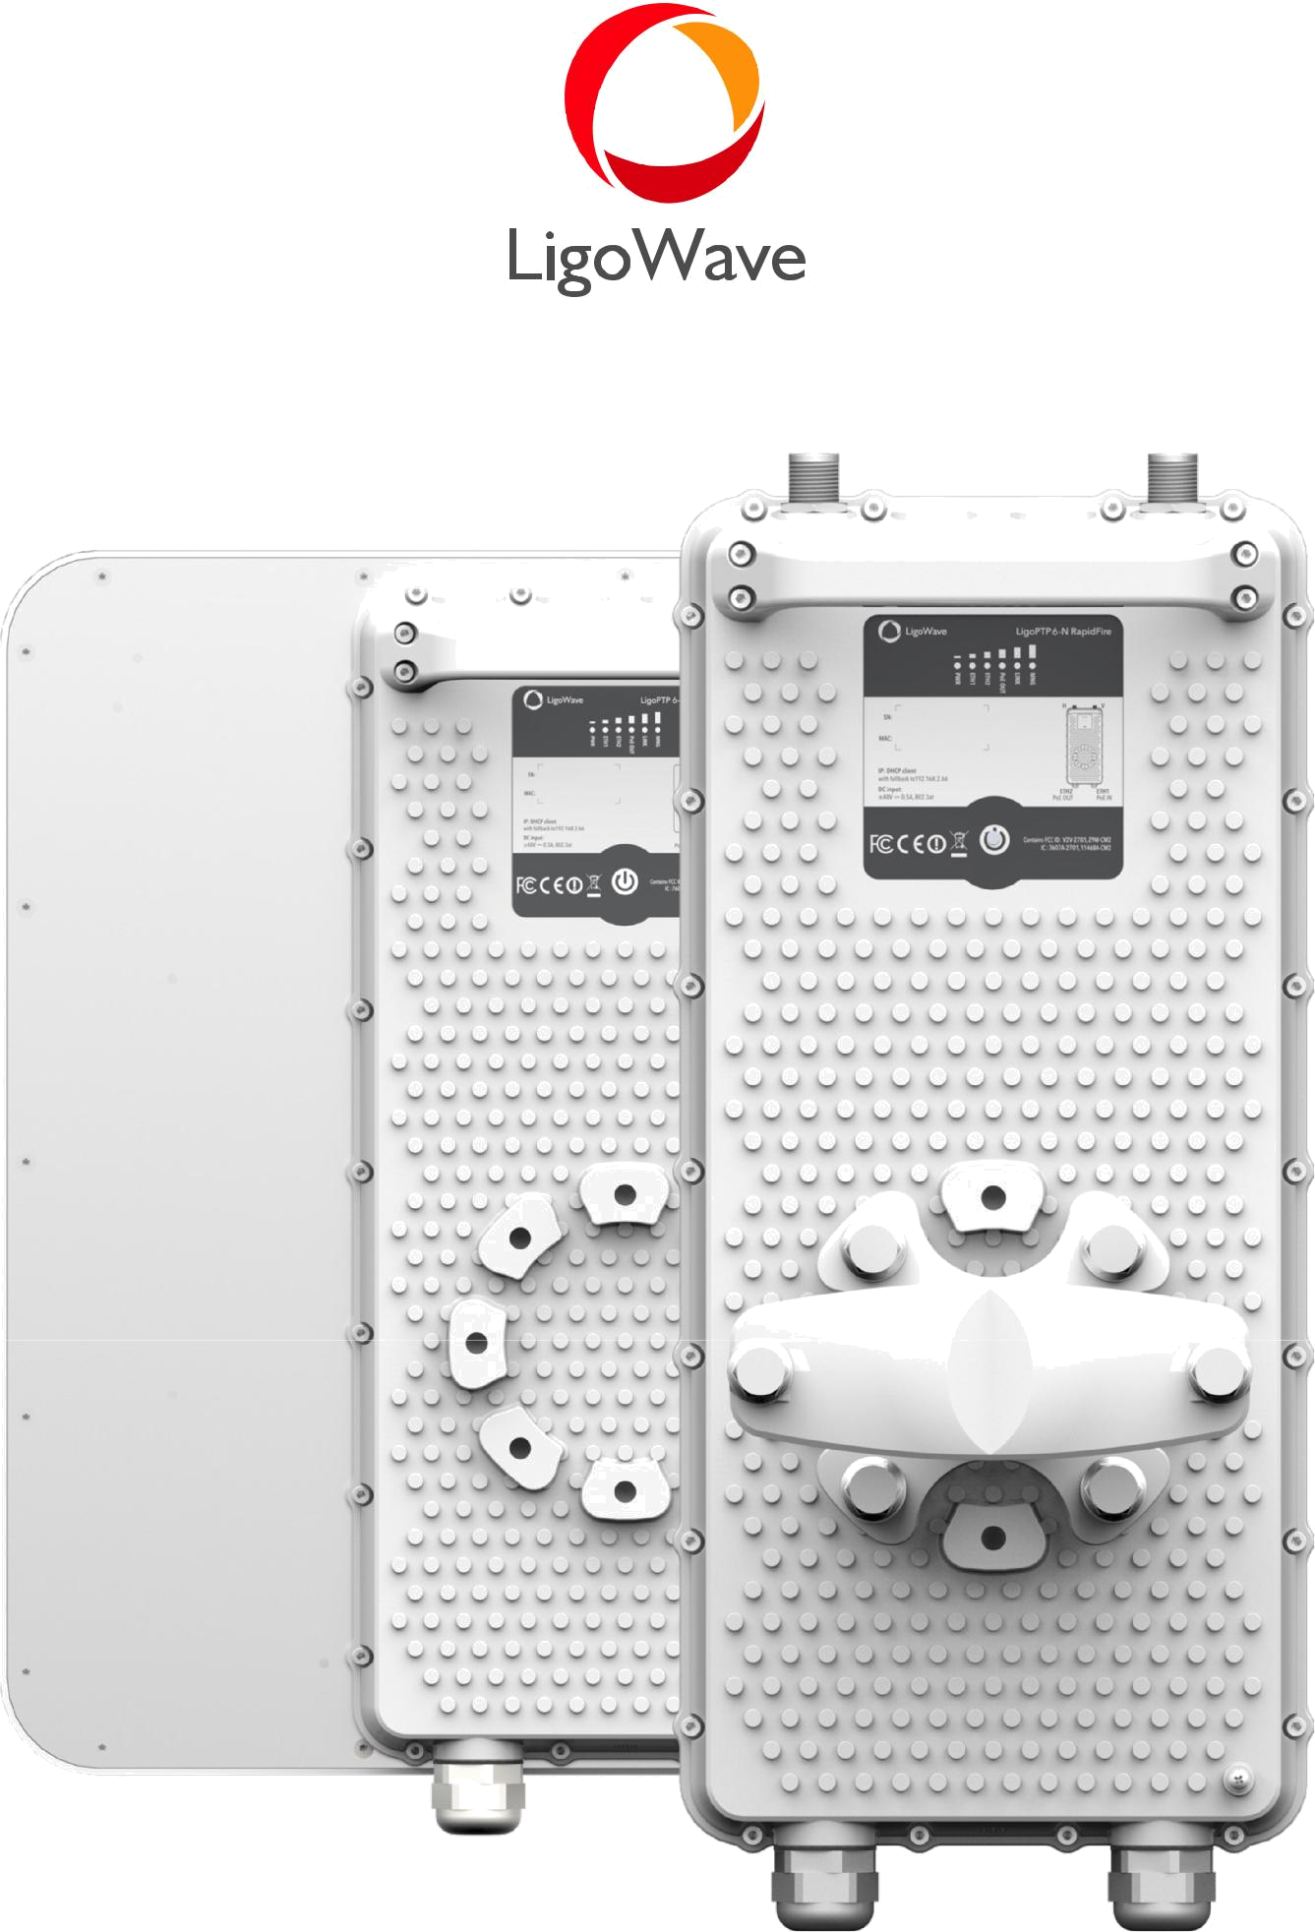

LigoPTP 6-N/ 6-25 RapidFire

Outdoor Wireless Point-to-Point Bridge


COPYRIGHT ©2019 LIGOWAVE
COPYRIGHT ©2019 LIGOWAVE


The 6GHz Generation

The LigoPTP RapidFire 6 — an extension of the time-tested LigoPTP line of wireless data transfer devices — empowers users to deliver superb connectivity over 6GHz frequencies. The 6GHz band provides more leg room for all types of wireless networks, allowing users to find minimally crowded channels, experience less noise and interference, and achieve greater range and throughput.


Outstanding Capacity

RapidFire delivers an extremely high 700Mbps throughput via its unique and powerful RF design that supports up to 256-QAM modulation and 30dBm output power. Our proprietary W-Jet V protocol, specifically engineered for high performing PTP scenarios, minimizes interferences even across long distances and stabilizes latency within 2-4 ms.


45°

Professional Design

In addition to achieving maximum performance, LigoWave focuses on delivering flexibility and ease-of-use in our RapidFire series. The robust mounting bracket enables rapid deployment of the links and ensures survivability during high wind-load. The integrated antenna possesses a 45° rotation option which increases installation flexibility; especially advantageous in noisy spectrum areas. A GORE© membrane vent allows fast pressure equalization of the IP-67 rated cast aluminum enclosure to prevent condensation and to ensure seal performance . A detachable handle eases transporting the devices up towers and over rough terrains. Newly designed RGB LEDs indicate different device statuses and signal levels (in 1dBm steps) when aligning the antenna.

COPYRIGHT ©2019 LIGOWAVE


Powerful All-in-One Hardware Platform
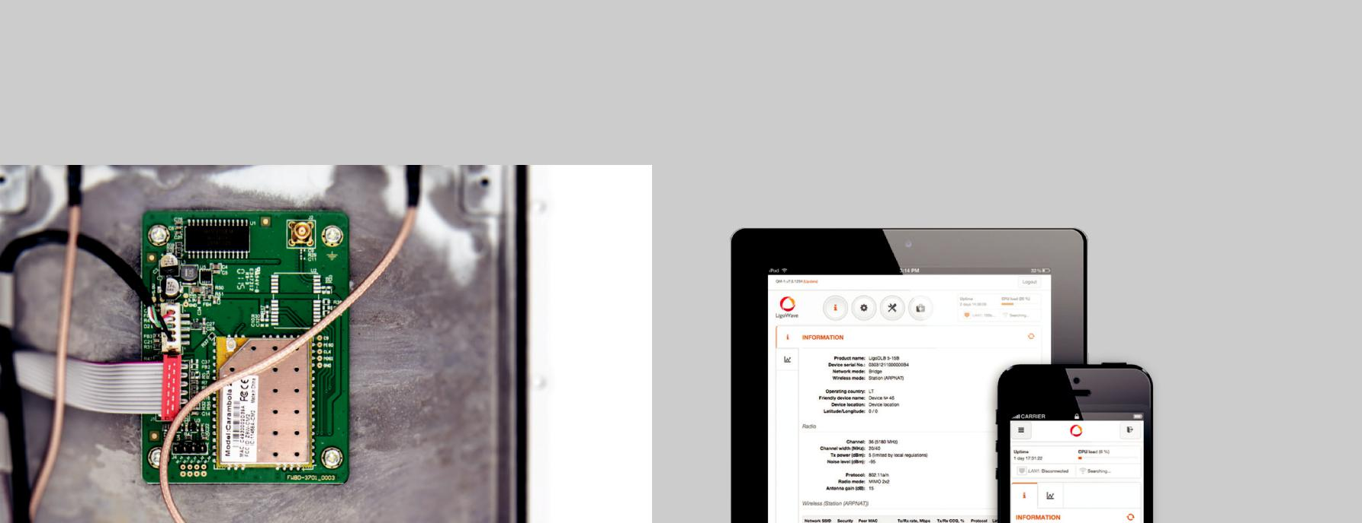

LigoWave RapidFire delivers powerful performance with its new 1.2GHz CPU dedicated for data processing and high (200,000) packet per second delivery. Equipped with two Gigabit Ethernet ports, one with PoE passthrough, the unit allows for 1+1 (failover) or repeater links and is ideal for high-security video surveillance scenarios. RapidFire incorporates integrated surge and ESD protection according to IEC standards and passes Class 4 requirements.

Wireless Configuration Interface

An internal 2.4GHz radio allows access into the Rapidfire GUI by wireless connection with any WIFI equipped device. This feature expedites the installation of links and alleviates the problem of troubleshooting in difficult-to-reach locations. Tests prove accessibility even when mounted on top of a 10-story building while standing 20 meters (65ft) away!
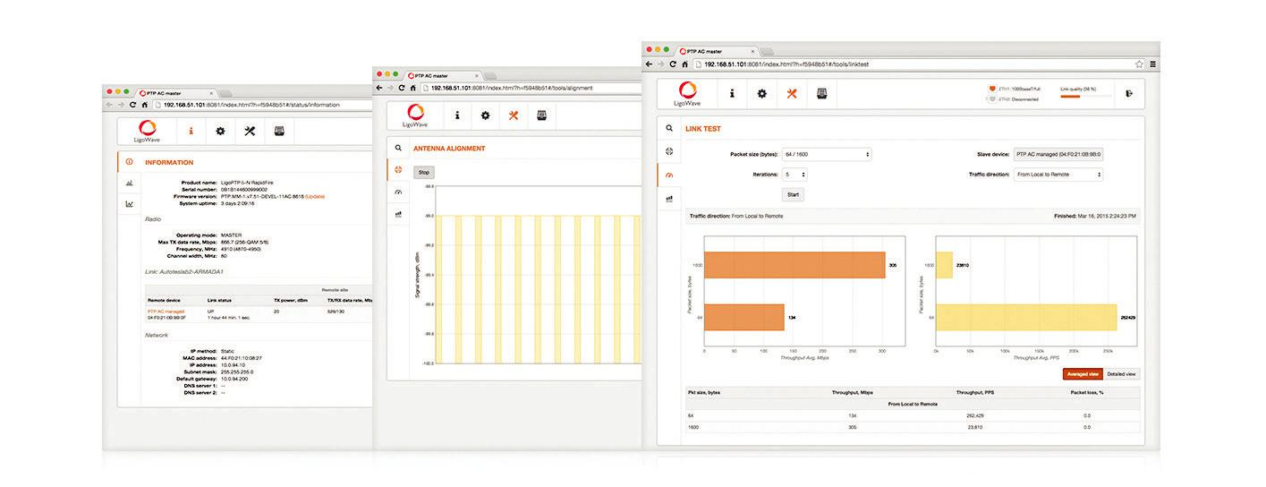

Powerful OS

The LigoPTP operating system ensures easy and rapid deployment of point-to-point links with stable, fast performance. An intuitive and responsive user interface adjusts the layout based on the size of your screen. Essential tools including Setup Wizard, link test, antenna alignment, spectrum analyzer, and site survey are included to make set-up and troubleshooting more efficient. Automatic mechanisms such as auto-channel and automatic transmit power control optimize the link for maximum performance even in areas with high interference.

COPYRIGHT ©2019 LIGOWAVE
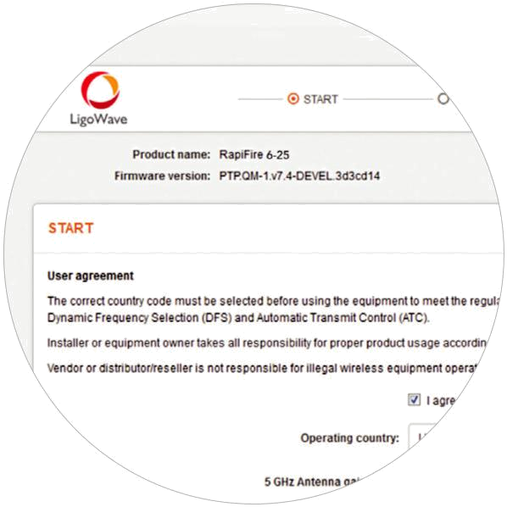
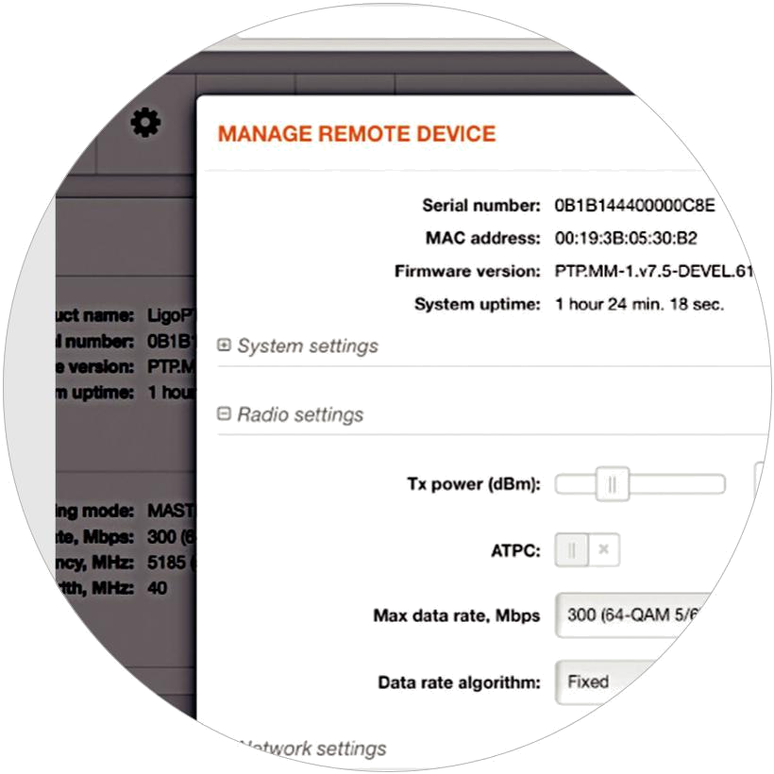

Setup Wizard | Single Side Configuration
A link setup wizard guides the installer through the important | LigoPTP RapidFire simplifies link configuration by supporting
steps of the set-up process. | single side configuration as parameters are automatically
 | applied to slave units once set on the master side.

Easy Pre-Configuration

Multiple options to pre-configure LigoPTP RapidFire devices are displayed in a scheme below. Devices can be connected with each other using wired or wireless connectivity. End-user device can also connect to the master device using 2.4GHz access radio or using wire to the Ethernet port of the master device. LigoPTP RapidFire devices can be discovered using bonjour and SSDP protocols as well.

Wireless
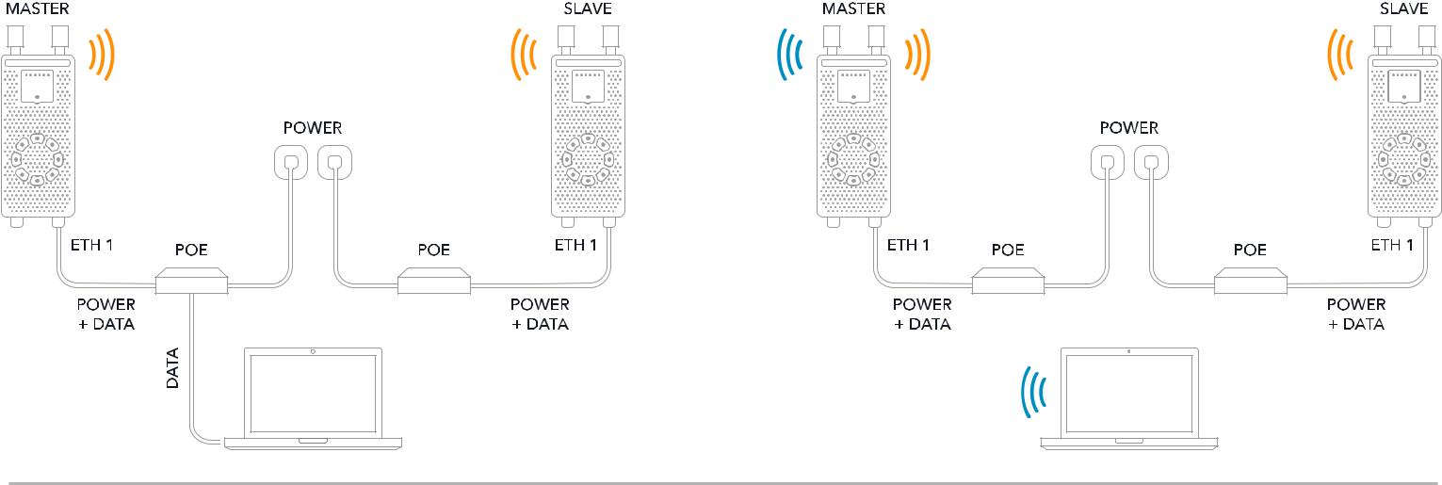

Wired

MASTER SLAVE
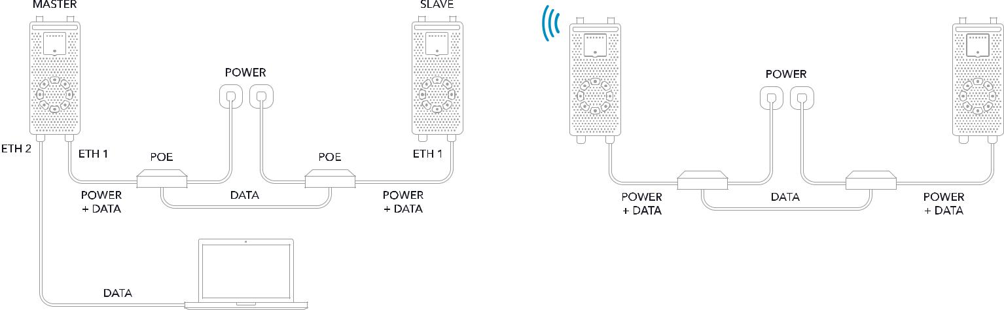

ETH 1 ETH 1


COPYRIGHT ©2019 LIGOWAVE
802.3af/at Inserter
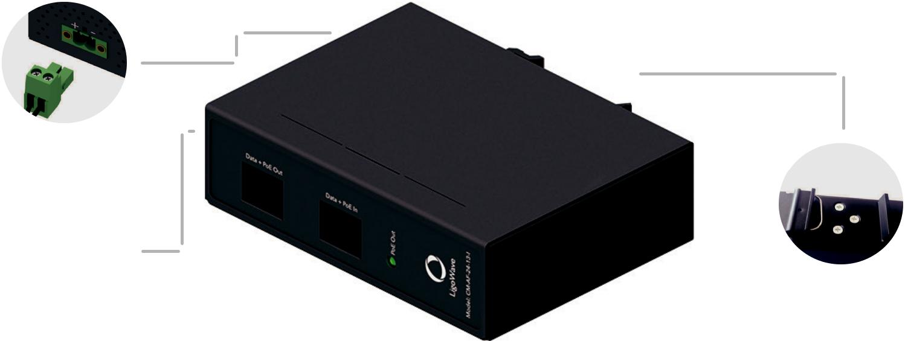

DC input connector

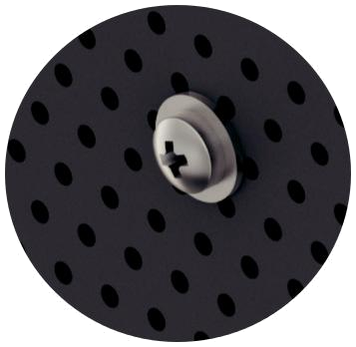

DIN rail mounting

Grounding pin
Electrical specifications |  | Physical specifications
DC input voltage range | 44.0–57.0V | DC input
IEEE 802.3af/at compliant | POE output | Data input jack | RJ45
Output power | up to 28W | Data + Power output jack | RJ45
Power output | RJ45 pins 1,2,4,5 (+) and 3,6,7,8 (-) | Dimensions | 117×87×34mm
Data rate | 10/100/1000Mbps | Weight | 270g
Surge protection | 2kV line to line, | Operating temperature | –40 to +65C
 | 6kV line to ground (output port) | UTP/FTP cable length | 100m total
 |  |  | (from switch to the device)

COPYRIGHT ©2019 LIGOWAVE
Radio

Wireless Protocol Radio Mode Frequency Range Channel Size Modulation Schemes Data Rates @ 80MHz Duplexing Scheme Error Correction Automatic TPC

Modulation, Mbps

Tx Power, dBm

Receive Sensitivity, dBm

Antenna

LigoPTP 6-25 RapidFire LigoPTP 6-N RapidFire

W-Jet V

MIMO 2×2

5.900–6.400GHz

5, 10, 20, 40, 80MHz

OFDM (256-QAM, 64-QAM, 16-QAM, QPSK, BPSK)

866, 780, 650, 585, 520, 390, 260, 195, 130, 65Mbps

TDD

BCC, LDPC

Supported


866 | 780 | 650 | 585 | 520 | 390 | 260 | 195 | 130 | 65
24 | 25 | 26 | 27 | 28 | 30 | 30 | 30 | 30 | 30
-71 | -73 | -77 | -79 | -80 | -84 | -87 | -92 | -94 | -97

Integrated Directional Dual-Pol 25dBi Panel

2 N-type Connectors

Wired

First Interface | 10/100/1000 | Base-T with PoE IN (RJ45)
Second Interface | 10/100/1000 | Base-T with PoE OUT (RJ45)

Physical

Dimensions without mount:

LigoPTP 6-25 RapidFire Length 379mm (14.9‘’), Width 387mm (15.2‘’), Height 51mm (2‘’)

LigoPTP 6-N RapidFire Length 399mm (15.7‘’), Width 174mm (6.8‘’), Height 47mm (1.8‘’)

Mount Length Till Pole 124mm (4.8‘’)

Weight including mount:

LigoPTP 6-25 RapidFire 3.9kg (8.5lb)

LigoPTP 6-N RapidFire 2.9kg (6.3lb)

Power

Power Input Method, Voltage PoE 802.3at, Isolated 42–57VDC

Max Power Consumption 8.6W

Power Output Method, Voltage PoE 802.3af, 48VDC, 12.95W Maximum

PoE Inserter and AC/DC Adapter are Included

Environmental

Operating Temperature –40°C (–40°F) ~ +65°C (+149°F)

Humidity 0~90% (Non-Condensing)

COPYRIGHT ©2019 LIGOWAVE
Software features

- Wizard for fast link setup

• Centralized control from master: A) Common wireless link parameters; B) Individual slave parameters

- Smart Auto-channel

- Robust data security

- QoS with hardware acceleration

- Spectrum analyzer

- Wireless signal and device state indication on RGB LEDs

- Dual firmware image

Management

Dedicated 2.4GHz Radio for Management

System Monitoring

System Configuration

STP/SNMP (V1), GUI/HTTP(S), Shell/SSH and WNMS GUI/HTTP(S) and WNMS

Regulatory

Certification

CE

Antenna specifications

 |  |  |  |  | V Pol |  |  |  |  |  |  |  |  |  |  |  | H Pol
 |  | 0 |  |  |  |  |  | 0 |  |  |  |  |  | 0 |  |  |  |  |  | 0
30 |  |  | 330 |  |  |  | 30 |  | 330 |  |  |  | 30 |  | 330 |  |  |  | 30 |  | 330
60 |  |  | 300 |  | 60 |  |  |  | 300 |  | 60 |  |  |  | 300 |  | 60 |  |  |  | 300
90 |  |  |  | 270 | 90 |  |  |  |  | 270 | 90 |  |  |  |  | 270 | 90 |  |  |  |  | 270
120 |  |  | 240 |  | 120 |  |  |  | 240 |  | 120 |  |  |  | 240 |  | 120 |  |  |  | 240
150 |  |  | 210 |  |  |  | 150 |  | 210 |  |  |  | 150 |  | 210 |  |  |  | 150 |  | 210
 |  | 180 |  |  |  |  |  | 180 |  |  |  |  |  | 180 |  |  |  |  |  | 180
 |  | Azimuth |  |  |  |  |  | Elevation |  |  |  |  |  | Azimuth |  |  |  |  |  | Elevation


Frequency Range | 5.85–6.45GHz
Gain | 25dBi
Cross-Pol Isolation | 27dB
VSWR | <1.4
Azimuth Beamwidth (H-pol) | 8°
Azimuth Beamwidth (V-pol) | 8°
Elevation Beamwidth | 8°


LigoPTP 6-N/ 6-25 RapidFire

Copyright © 2019 LigoWave. All rights reserved. LigoWave, the LigoWave logo, are trademarks of LigoWave. All other company and product names may be trademarks of their respective companies. While every effort is made to ensure the information given is accurate, LigoWave does not accept liability for any errors or mistakes which may
arise. Specifications and other information in this document may be subject to change without notice. To learn more about LigoWave products, visit www.ligowave.com.
COPYRIGHT ©2019 LIGOWAVE

